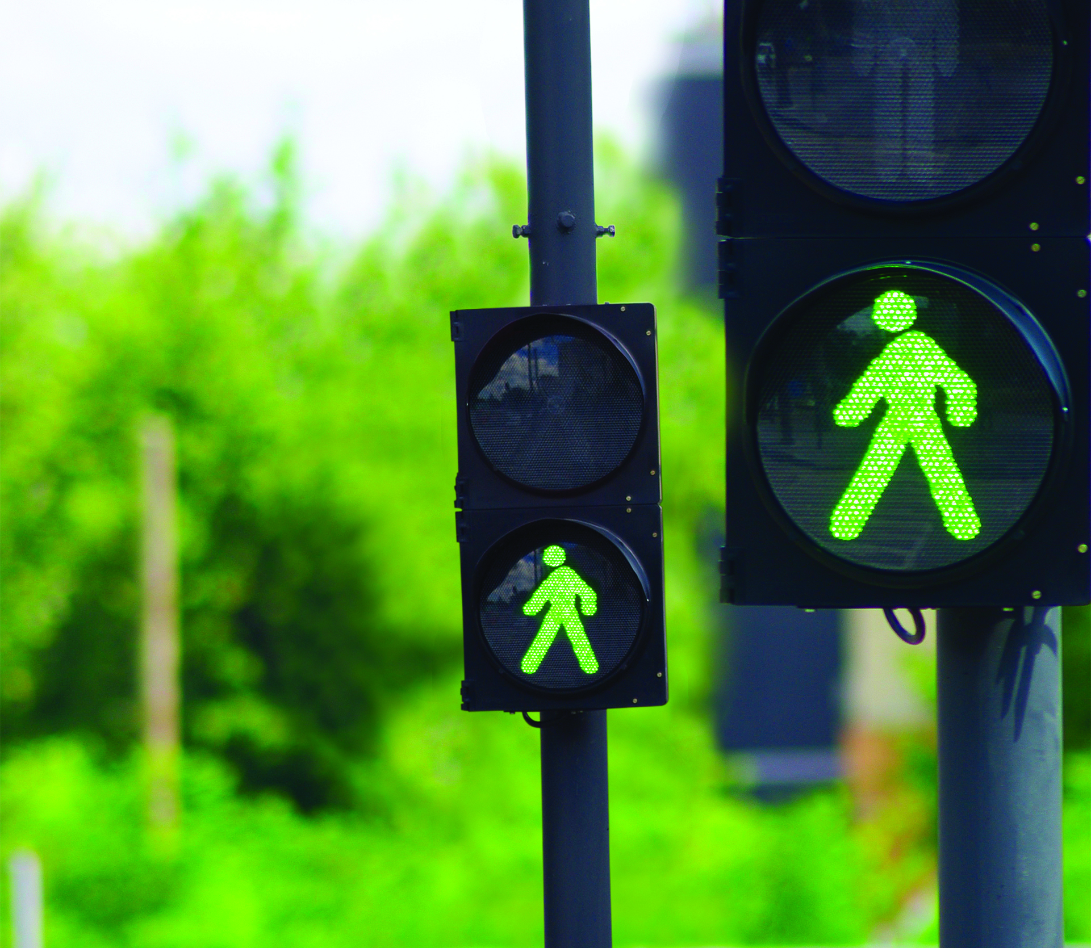

TRAFFIC LIGHT CONTROL

Ibrahim Elsayed Mostafa

December Cohort

Static Design

FWD PRO

# System Description

On-demand traffic light control project introduce more flexibility and higher priority to the pedestrian over the cars unlike the traditional ones. It allows the pedestrian to stop the flow of the cars through a push button otherwise it works just like a traditional traffic light control.

# System Design

The system is designed according to the layered architecture principles.

|  |  |
| --- | --- |
| Layer | Driver |
| Application Layer | Application Code |
| ECUAL | Buttons & Switches |
| MCAL | DIO & External Interrupt & Timer |
| Microcontroller | Atmega32a |

HARDWARE

# Atmega32a

* + The system controller.

# LEDS 6

* + 3 indicators for cars and the other 3 for the pedestrian.
  + The car`s leds are connected to porta (pin0, pin1, pin2).
  + The pedestrian`s leds are connected to portb (pin0, pin1, pin2).
* **BUTTONS 1**
  + The button is responsible for call the routine for the presence of pedestrians waiting to cross the street.
  + Chart, diagram, schematic

    Description automatically generatedThe button is connected to portd (pin2).

DRIVERS

* **DIO**
  + Control the digital input/output pins.
  + Consists of 4 main functions (initialization – write – read - toggle).
  + The initialization function specifies the direction of the pin whether input or output.
  + The write function specifies the logic on the output pin whether high or low.
  + The read function returns the logic on the input pin whether high or low.
  + The toggle function toggles the output pin logic state.
* **Timer**
  + Control the timing in the system and introduce the needed delays.
  + Consists of 4 main functions (initialization – start – delay – stop).
  + The initialization function manipulates the timer registers to prepare it.
  + The start function state the prescalar value and start the timer.
  + The delay function calculates the needed values to be assigned to the timer registers and introduce the required delay.
  + The stop function reset the timer.
* **External Interrupt**
  + Makes the external changes to system which needs a certain routine to be served.
  + Consists of 4 main functions (initialization – enable – disable – call-back).
  + The initialization function state which external interrupt to be ready and on which mode it will work.
  + The enable function starts the specified external interrupt work and then the external changes could take effect.
  + The disable function stops the specified external interrupt work.
  + The call-back function assigns the given function to be executed upon calling the specified external interrupt.
* **Led**
  + Control the state of the led through 3 functions (on – off – toggle).
* **Button**
  + Read the state of the switch through one function (read).

Constraints

# Double press on the button

* + The first press takes effect only.

# Long press on the button

* + Nothing to be done as the system affected by rising edge only.

Flowchart

